1. Get the list of employee details which should include their name,department and name of the insurance type
ans ->
SELECT name, dept_name, insurance_name
FROM Employee_Table as et
JOIN Department_Table as dt
ON et.dept_id = dt.dept_id
JOIN Insurance_Table as it
ON et.insurance_id = it.insurance_id;
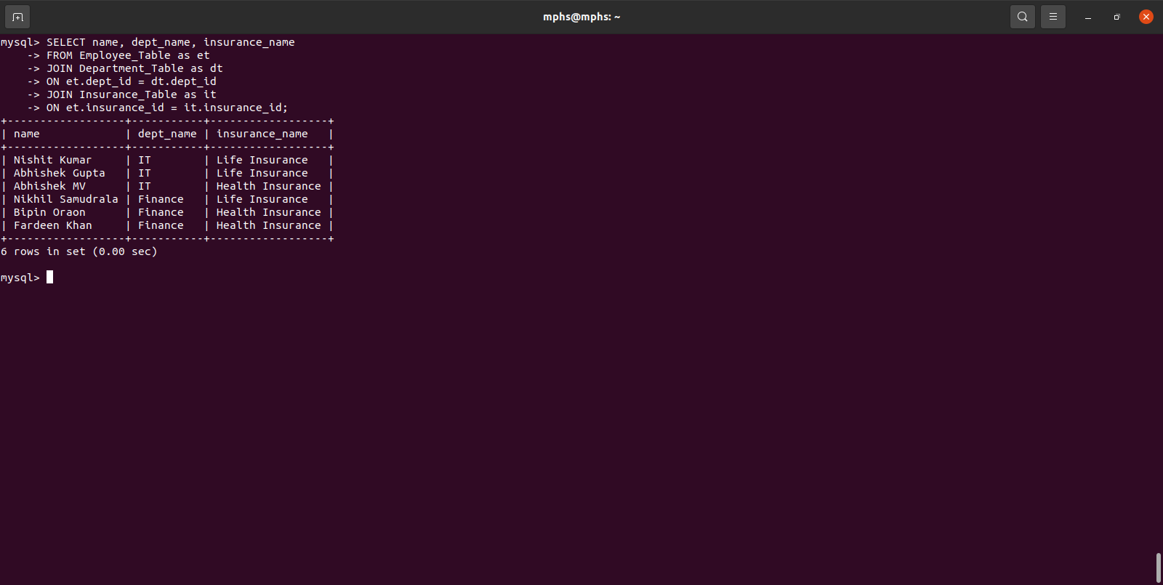

2.Get the list of departments of employees working at particular place(e.g: Madhapur)
ans ->
SELECT et.name , ot.place
FROM Employee_Office_Table as eot
JOIN Employee_Table as et
ON eot.emp_id = et.emp_id
JOIN Office_Table as ot
ON eot.office_id = ot.office_id
WHERE ot.place = 'Milange Towers';

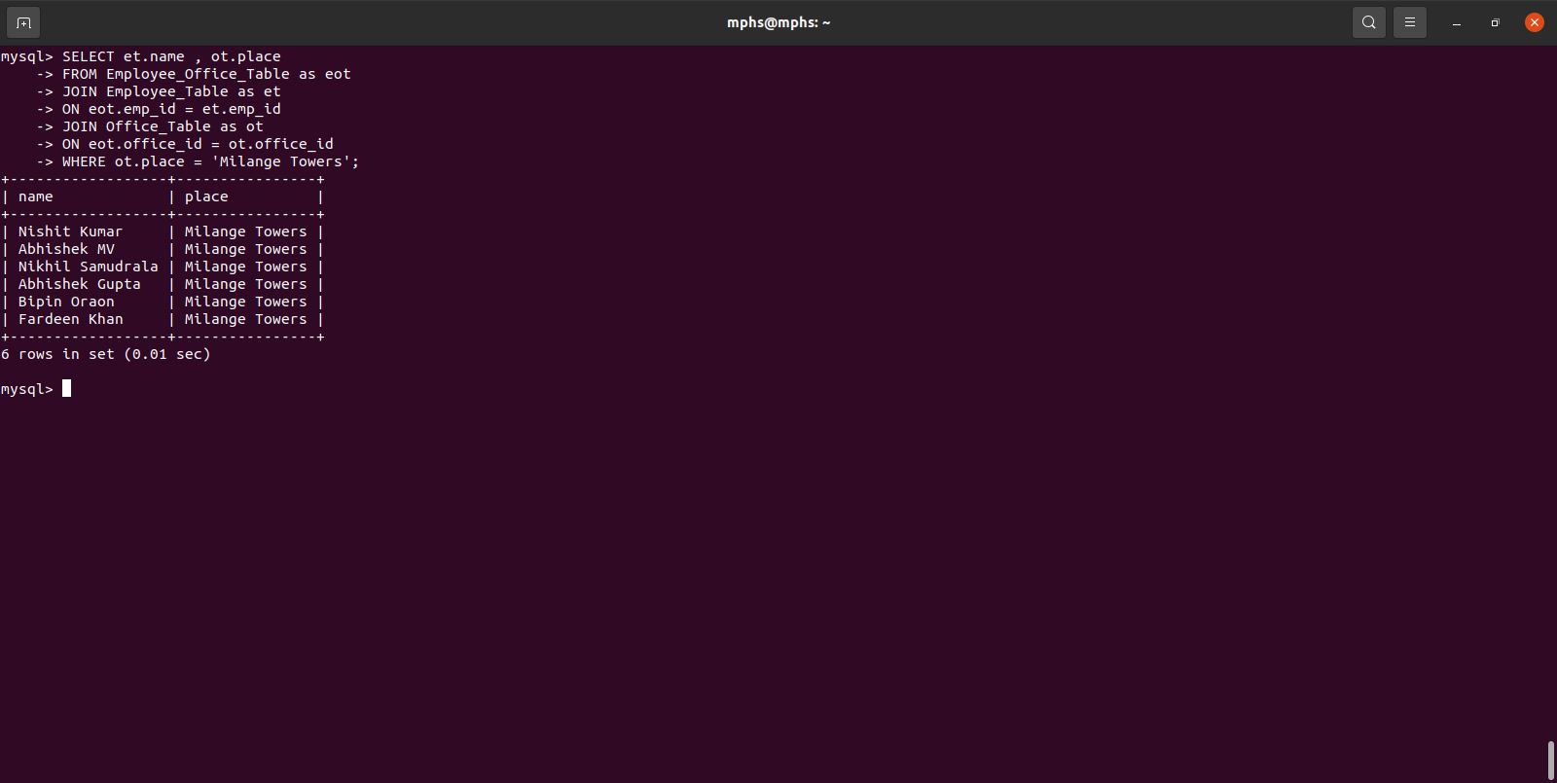
3.Get the count of employees working in each location
ans ->
SELECT COUNT(et.name) as emp_cnt , ot.place
FROM Employee_Table as et
JOIN Employee_Office_Table as eot
ON et.emp_id = eot.emp_id
JOIN Office_Table as ot
ON ot.office_id = eot.office_id
GROUP BY ot.place;
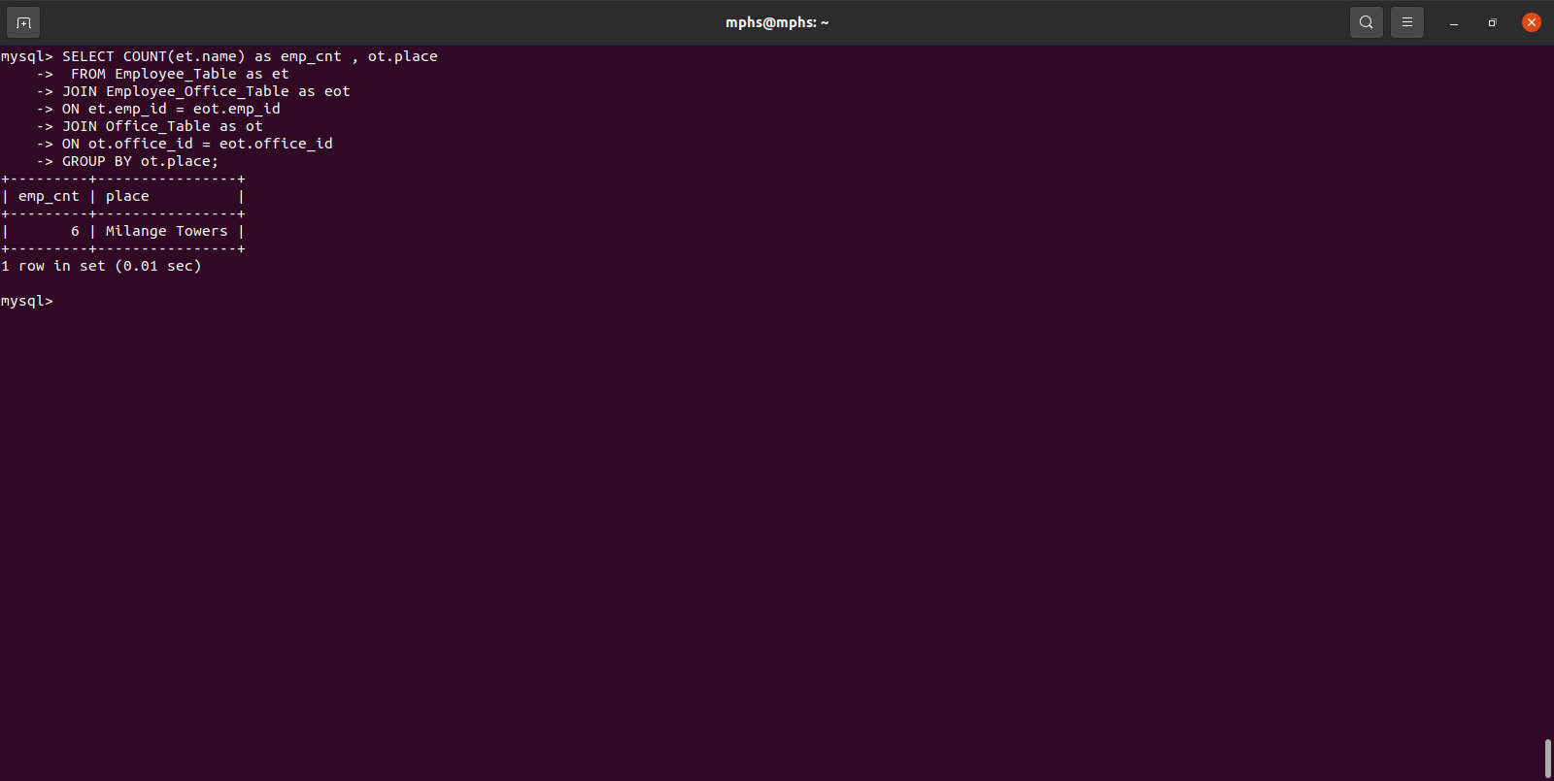

4.Get the third highest salaried employee name, insurance name and salary(Joins)
ans ->
SELECT * FROM (
SELECT et.name, it.insurance_name, eot.salary
FROM Employee_Table as et
JOIN Insurance_Table as it
ON et.insurance_id = it.insurance_id
JOIN Employee_Info_Table as eot
ON et.employee_info = eot.id
ORDER BY eot.salary DESC LIMIT 3) as T
Order BY salary LIMIT 1 ;

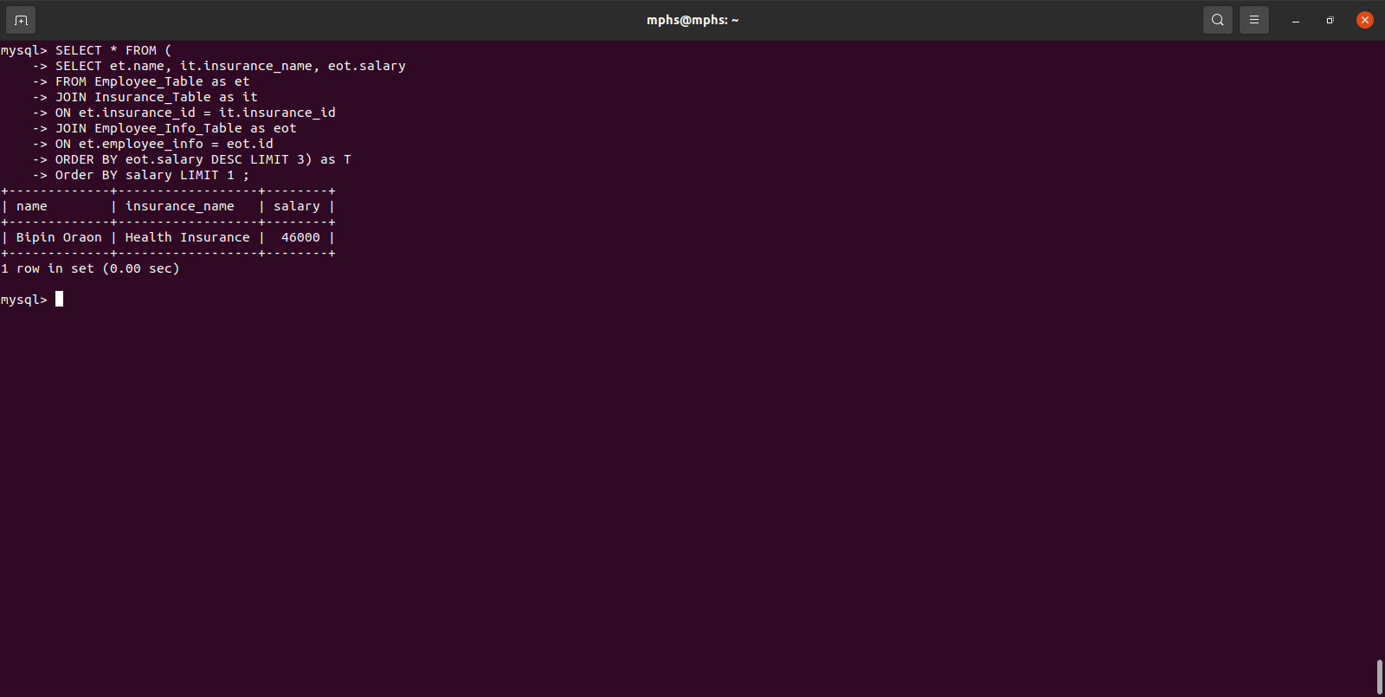
5.Get the Average salary of employees from each department for a particular location
ans ->
SELECT AVG(eit.salary), dt.dept_name
FROM Employee_Table as et
JOIN Employee_Info_Table as eit
ON et.employee_info = eit.id
JOIN Department_Table as dt
ON et.dept_id = dt.dept_id
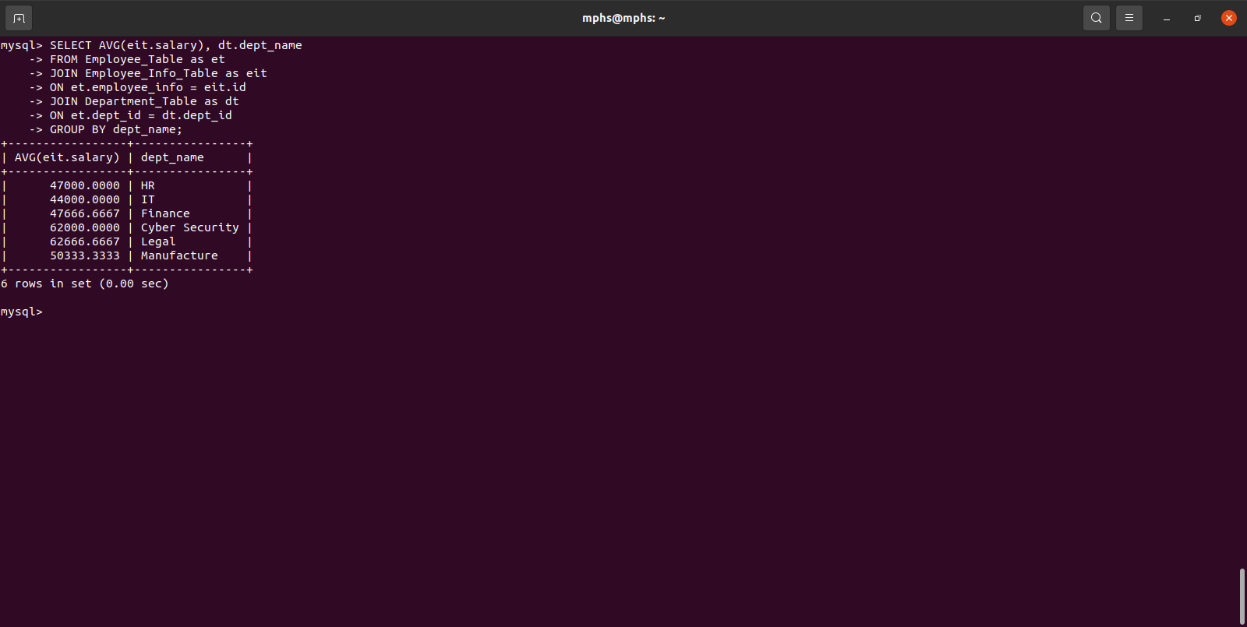
GROUP BY dept_name;

6.Get the sum of salaries of the employees joined after 02-01-2022 working in ‘Madhapur’
ans ->
SELECT SUM(eit.salary), ot.place
FROM Employee_Table as et
JOIN Employee_Info_Table as eit
ON et.employee_info = eit.id
JOIN Employee_Office_Table as eot
ON eot.emp_id = et.emp_id
JOIN Office_Table as ot ON ot.office_id = eot.office_id
WHERE place = "Milange Towers" AND DOJ > "2022-02-10"
GROUP BY (ot.place);

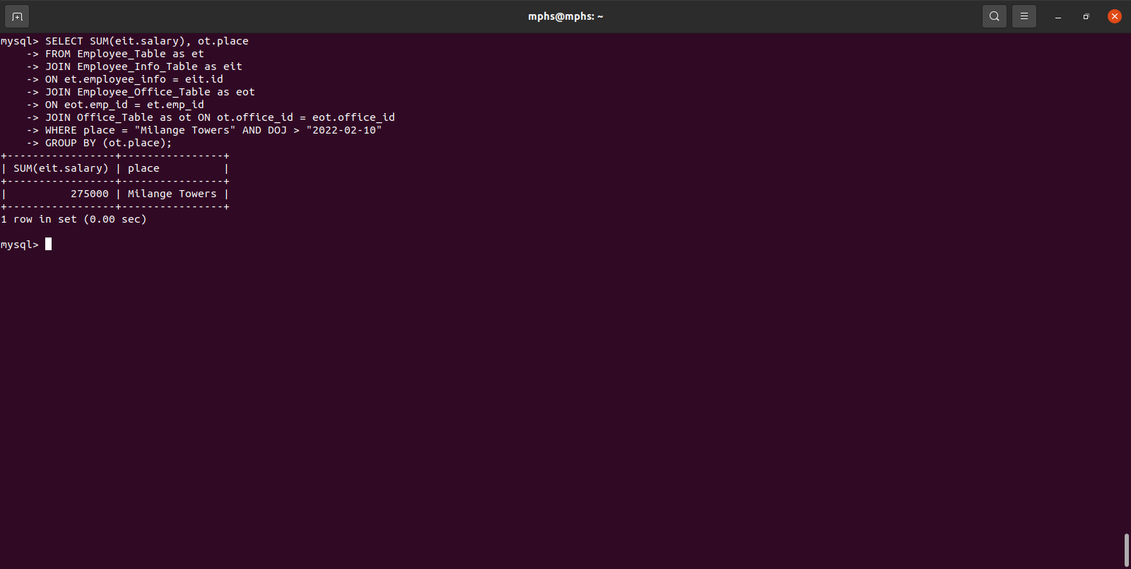
7.Get name, department, salary of employees who joined after 20-02-2022 and salary is greater than 20000 and has insurance either in lic or icici or both and whose work location is madhapur.

ans ->
SELECT et.name, dt.dept_name, eit.salary, it.insurance_name
FROM Employee_Table as et
JOIN Department_Table as dt
ON et.dept_id = dt.dept_id
JOIN Employee_Info_Table as eit
ON eit.id = et.employee_info
JOIN Insurance_Table as it
ON et.insurance_id = it.insurance_id
WHERE eit.salary > 40000
AND (it.insurance_name = 'icici' OR it.insurance_name = 'lic');

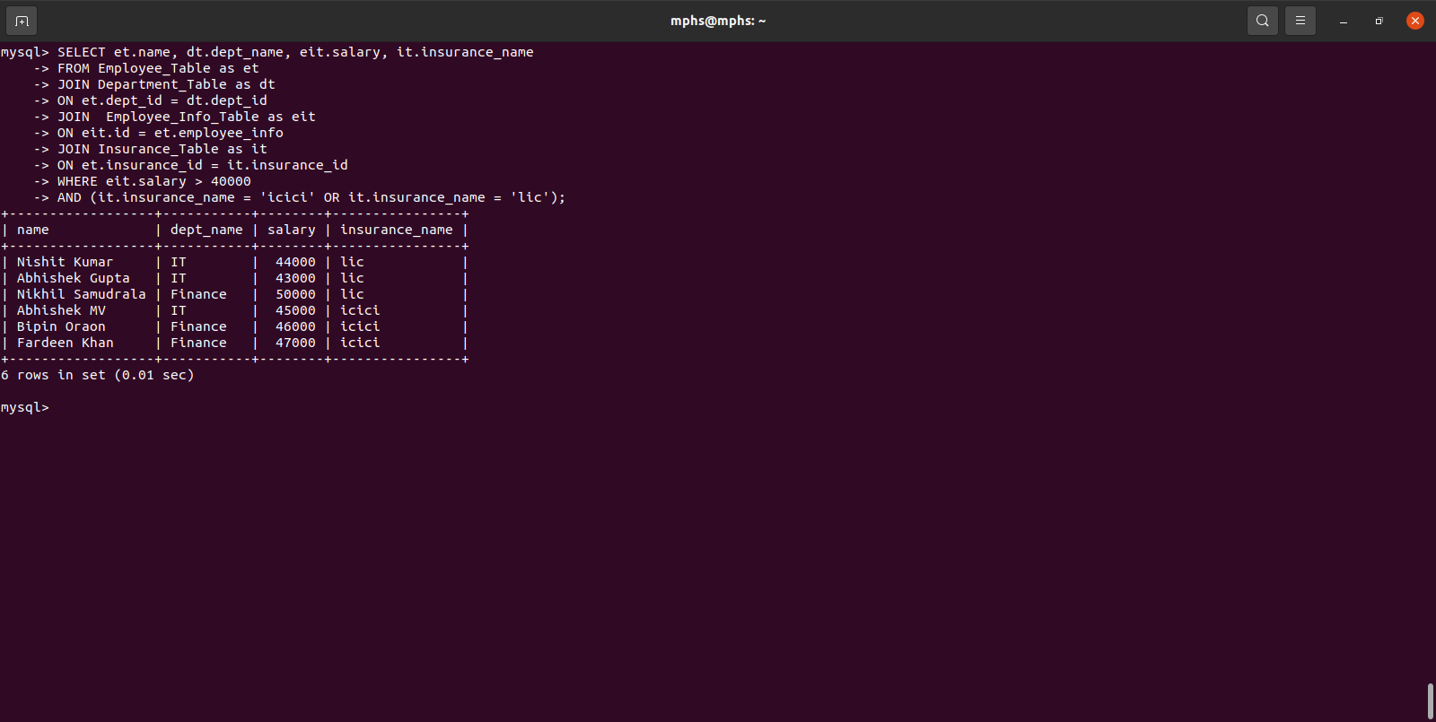
8. Get the list of employee names and their respective immediate head name

ans ->
SELECT et.name as Employee, IFNULL(ht.name, "NO HEAD") as Head
FROM Employee_Table as et
LEFT JOIN Employee_Table as ht
ON et.immediate_head_id = ht.emp_id;
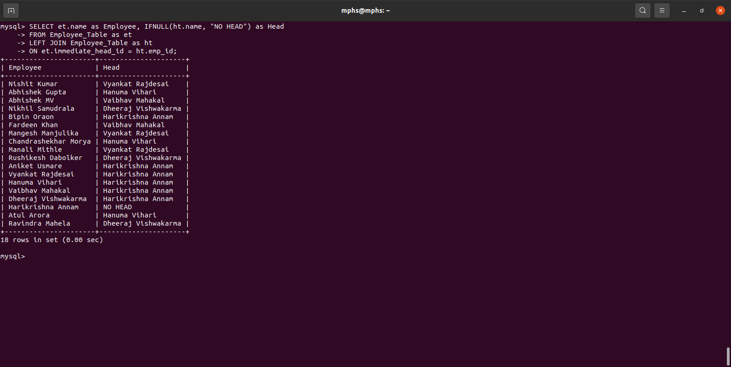

9. Get the list of employee names and their respective immediate head name with their respective department names.

ans ->

SELECT et.name, dt.dept_name, ht.name, hdt.dept_name
FROM Employee_Table as et
JOIN Department_Table as dt
ON et.dept_id = dt.dept_id
JOIN Employee_Table as ht
ON et.immediate_head_id = ht.emp_id
JOIN Department_Table as hdt
ON ht.dept_id = hdt.dept_id;

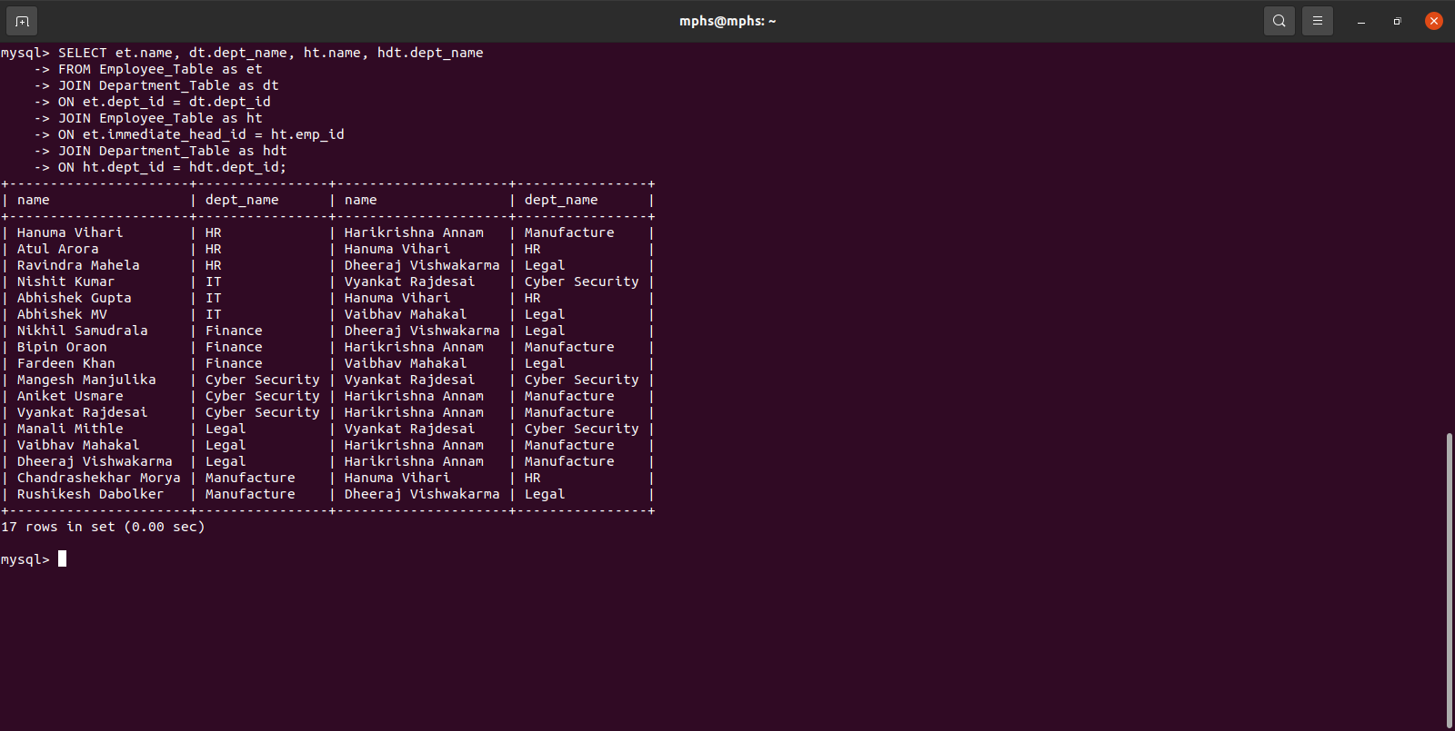

10. Get the list of employees whose immediate head working in location ‘madhapur’ and whose salary is less than twice the salary of their respective immediate heads.
Ans ->
SELECT et.name as Employee, ht.name as Head
FROM Employee_Table as et
JOIN Employee_Info_Table as eit
ON et.employee_info = eit.id
JOIN Employee_Table as ht
ON et.immediate_head_id = ht.emp_id
JOIN Employee_Info_Table as hit
ON ht.employee_info = hit.id
JOIN Employee_Office_Table as eot
ON et.emp_id = eot.emp_id
JOIN Office_Table as ote
ON ote.office_id = eot.office_id
JOIN Employee_Office_Table as hot
ON ht.emp_id = hot.emp_id
JOIN Office_Table as oth
ON oth.office_id = hot.office_id
WHERE hit.salary > 2 * eit.salary
AND oth.place = "Milange Towers";

